

**Model Optimization and Tuning Phase Template**

|  |  |
| --- | --- |
| Date | 09 JULY 2024 |
| Team ID | 740024 |
| Project Title | Evolving efficient classification patterns in Lymphography |
| Maximum Marks | 10 Marks |

**Model Optimization and Tuning Phase**

The Model Optimization and Tuning Phase involves refining machine learning models for peak performance. It includes optimized model code, fine-tuning hyperparameters, comparing performance metrics, and justifying the final model selection for enhanced predictive accuracy and efficiency.

**Hyperparameter Tuning Documentation (6 Marks):**

crop

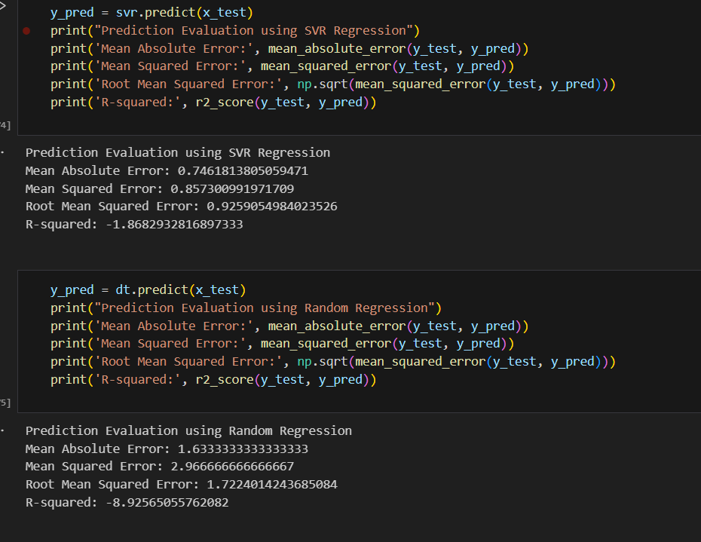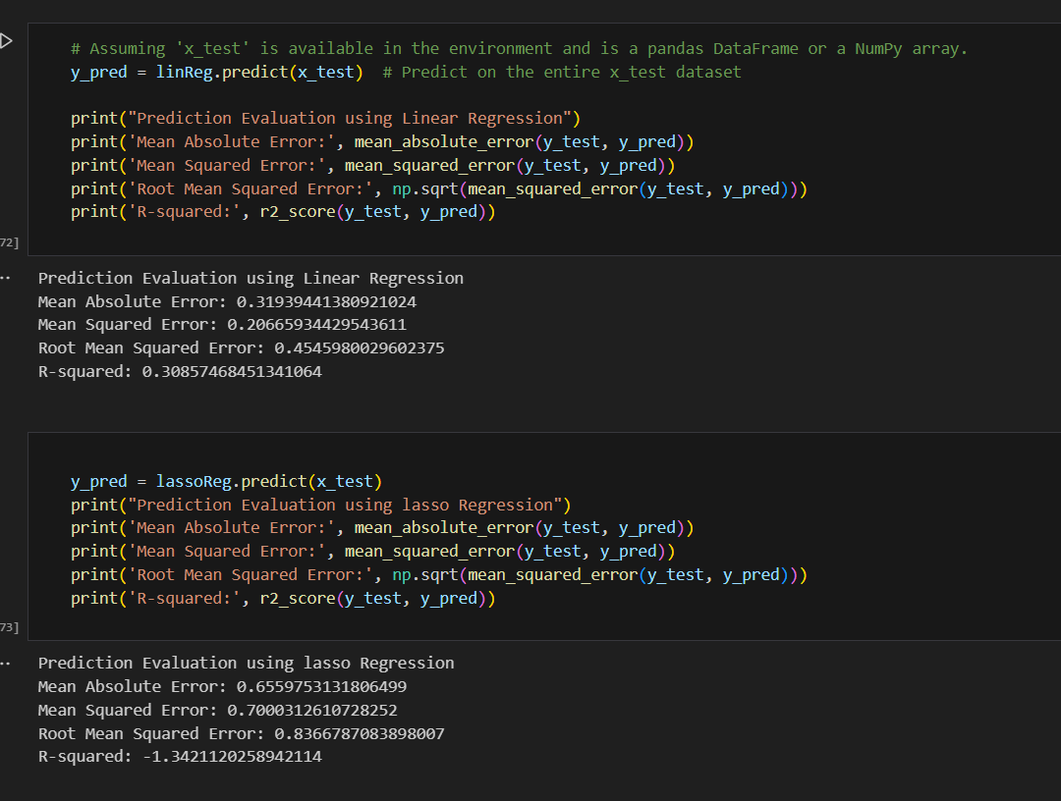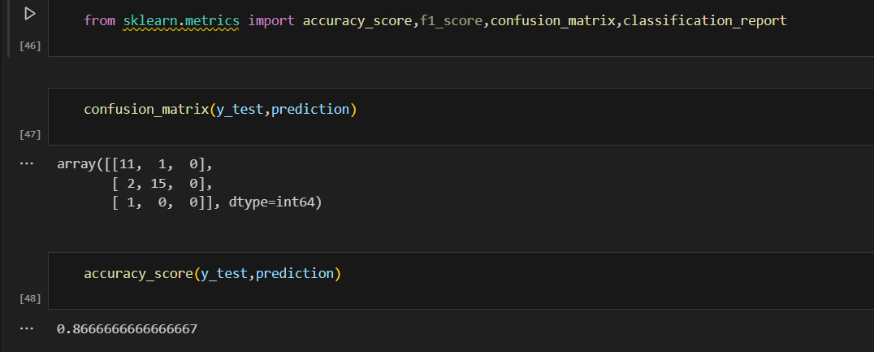



**Performance Metrics Comparison Report (2 Marks):**

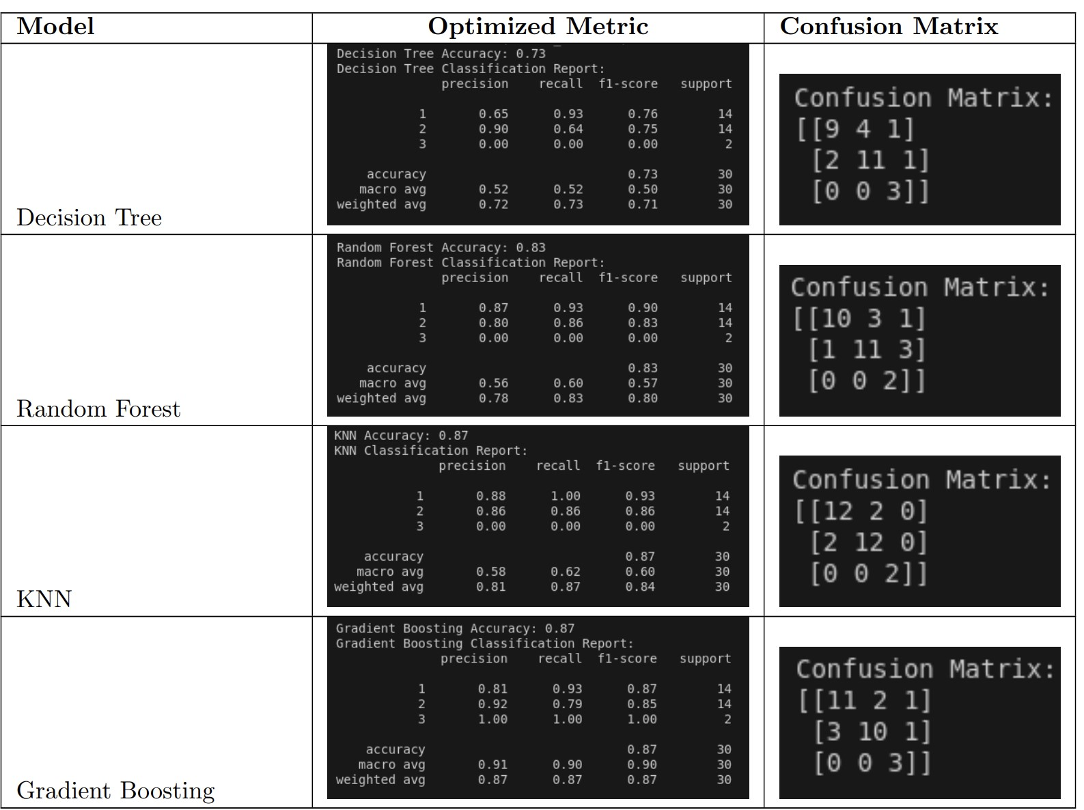

**Final Model Selection Justification (2 Marks):**

